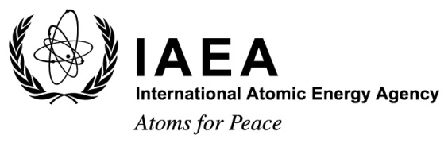

Fourth International Conference on

Nuclear Power Plant Life Management

Lyon, France, 23-27 October 2017

Ref No.: CN-246
BIOGRAPHICAL SUMMARY FOR SPEAKERS
NAME:
SESSION & TRACK # | Will be available soon in the draft programme on the web site
PAPER TITLE:
AFFILIATION/COMPANY:
SHORT BACKGROUND FOR INTRODUCTION (4-5 LINES) with photo | Photo

Release of Electronic Presentation

I agree that my electronic presentation presented at Fourth International Conference on Nuclear Power Plant Life Management to be held in Lyon, France, from 23 to 27 October 2017 may be made available on the IAEA conference app and/or website as a PDF.
YES  | NO  Signature:

Please complete and return this form by email to: plim2@iaea.org

