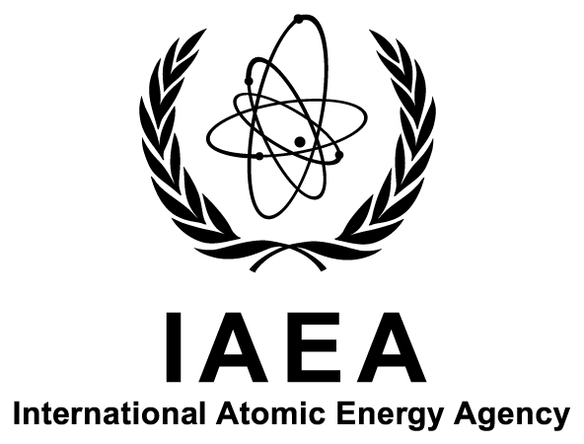

Department of Nuclear Sciences and Applications

IAEA Environment Laboratories, Monaco and Seibersdorf

14th Coordination Meeting of the
IAEA’s Network of Analytical Laboratories for the
Measurement of Environmental Radioactivity

(ALMERA)

Ref. No.: K4-TM-54643

Title: | 14th Coordination Meeting of the IAEA’s Network of Analytical Laboratories for the Measurement of Environmental Radioactivity (ALMERA)
Host Institute: | Swedish Radiation Safety Authority, Stockholm, Sweden
Dates: | 23–25 October 2017
Deadline for Nominations: | 12 May 2017
Organizers: | The International Atomic Energy Agency (IAEA) and the Swedish Radiation Safety Authority
Host Country Organizer: | Mr Mats Eriksson  Swedish Radiation Safety Authority  Solna strandväg 96  SE-171 16 STOCKHOLM  SWEDEN  Email: Mats.Eriksson@ssm.se
Language: | English
Background Information: | ALMERA (‘Analytical Laboratories for the Measurement of Environmental Radioactivity’) is a worldwide network of analytical laboratories, established by the IAEA. Through methodological and data quality support received from the IAEA and the development and validation of collaborative methods, ALMERA member laboratories are able to provide internationally acceptable radioanalytical data in normal situations as well as in case of accidental or intentional releases of radioactivity, as requested by their nominating authorities.  The ALMERA Network holds annual coordination meetings to discuss the implementation of planned activities and to define future activities of the Network. Within this context, ALMERA laboratories’ representatives are invited to attend the 14th Coordination Meeting of the ALMERA Network to be held from 23 to 25 October 2017 at the Swedish Radiation Safety Authority in Stockholm, Sweden.
Purpose: | The purpose of the meeting is to review ALMERA activities and to define a future work plan for developing the Network’s activities in the following fields: recommended radioanalytical methods, reference materials and proficiency testing, methodologies supporting routine and emergency environmental monitoring, and radioecological assessment.
Expected Outputs: | The expected outputs of the meeting are to:  - Present and discuss ALMERA proficiency test results and related proposals;  - Discuss the current status and plans for recommended radioanalytical procedures developed within the ALMERA Network;  - Discuss priorities for training courses and workshops;  - Discuss means for communication and data sharing and exchange among ALMERA laboratories;  - Discuss initiatives for regional cooperation and collaboration with other networks;  - Identify work plans and proposals for the ALMERA regional groups and task groups; and  - Review and update the general ALMERA work plan.
Scope and  Nature: | The meeting will provide an opportunity to undertake, at the senior technical level, a thorough review of the plan for future ALMERA activities. The meeting will also discuss how to further increase the role of regional coordination centres in mobilizing the Network’s experience, encouraging the exchange of expertise, and supporting capacity building at the regional level.  The meeting will consist of a plenary session and working sessions for regional groups and for task groups. The plenary session will include presentations by ALMERA members on developments in radioanalytical methods, quality systems and environmental radioactivity monitoring and assessment projects in their laboratories and presentations by IAEA specialists in relevant areas. The overall ALMERA work plan will be presented at the plenary session on Wednesday, 25 October 2017. The meeting agenda will be circulated in due course.
Participation: | The meeting is open to representatives from ALMERA Network member laboratories from IAEA Member States. All ALMERA representatives wishing to attend the meeting should be nominated by their Government (Ministry of Foreign Affairs or National Atomic Energy Authority). Nominations for participation (using Form A) should be received by the IAEA not later than 12 May 2017.  The ALMERA Network has laboratories in the following IAEA Member States:  Argentina, Australia, Austria, Bangladesh, Belarus, Belgium, Bosnia and Herzegovina, Brazil, Bulgaria, Canada, Chile, China, Costa Rica, Croatia, Cuba, Cyprus, Czech Republic, Denmark, Ecuador, Egypt, Estonia, Ethiopia, Finland, France, Germany, Greece, Hungary, Iceland, India, Indonesia, Islamic Republic of Iran, Iraq, Ireland, Italy, Jamaica, Japan, Jordan, Kazakhstan, Kenya, Republic of Korea, Kuwait, Latvia, Lebanon, Lithuania, Luxembourg, Madagascar, Malaysia, Malta, Mexico, Mongolia, Montenegro, Morocco, Myanmar, Netherlands, New Zealand, Norway, Pakistan, Panama, Peru, Philippines, Poland, Portugal, Qatar, Romania, Russian Federation, Saudi Arabia, Serbia, Singapore, Slovakia, Slovenia, South Africa, Spain, Sri Lanka, Sweden, Switzerland, Syrian Arab Republic, Tajikistan, Thailand, the former Yugoslav Republic of Macedonia, Tunisia, Turkey, Ukraine, United Arab Emirates, United Kingdom, United States of America, Uruguay, Bolivarian Republic of Venezuela, and Zambia.
Participants’ Qualifications: | Participants should be representatives of laboratories that are members of the ALMERA Network.
Nomination Procedure: | Nominations should be submitted through the established official channels not later than 12 May 2017 for the attention of the Scientific Secretary of the meeting, Mr Aurélien Pitois, ALMERA Scientific Coordinator, IAEA Environment Laboratories, Department of Nuclear Sciences and Applications, IAEA, Vienna International Centre, PO Box 100, 1400 Vienna, Austria (Tel.: +43 1 2600 28226; Fax: +43 1 26007; Email: A.Pitois@iaea.org). Nominations should also be copied to the Administrative Secretary for the meeting, Ms Barbara Massinger (Email: B.Massinger@iaea.org). The full names and complete contact details (including postal address, telephone/fax numbers, and email address) of nominated participants should be provided.  Nominations received after this date or which have not been routed through the established official channels cannot be considered.
Administrative and Financial Arrangements: | Nominating Governments will be informed in due course of the names of the candidates who have been selected and will, at that time, be given full details of the procedures to be followed with regard to administrative and financial matters.  A limited number of grants will be made available by the IAEA to non-local participants from developing countries. The Grant Application Form (Form C) should be submitted through the established official channels as soon as possible and no later than 12 May 2017. Selected participants will be provided with travel and subsistence expenses.  The organizers of the meeting do not accept liability for the payment of any cost or compensation that may arise from damage to or loss of personal property, or from illness, injury, disability or death of a participant while he/she is travelling to and from or attending the meeting, and it is clearly understood that each Government, in nominating participants, undertakes responsibility for such coverage. Governments would be well advised to take out insurance against these risks. Participants should also make their own arrangements for passports, visas, and vaccinations.

