Mobile Conference Application:
(for smart phones and tablets)

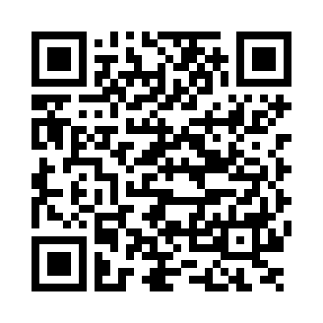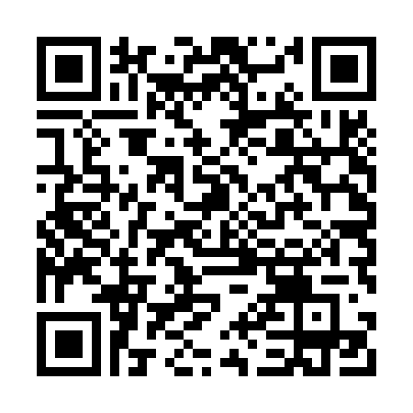
Android iPhone

Participants are encouraged to download the conference application (App) IAEA Conferences and Meetings, available at Google Play and the iTunes Store.

Once downloaded, simply go to this Conference.

The App has a number of very useful features. Inter alia it allows you to:
- access both oral and poster abstracts
- message other participants
- view the up-to-date programme
- view a list of participants
- receive announcements via push notifications
- and after the conference, access powerpoint presentations and slides of posters.

Login!
To enjoy all the features of the app please log in. To enable you to do this an event code will be emailed to you before the conference. If you do not have the event code please see the Conference Registration Desk (at the conference) and they will be able to provide you with it.

If you have questions or require assistance with the App, please contact the Conference Registration Desk (at the conference).

