Mobile Conference Application:
(for smart phones and tablets)

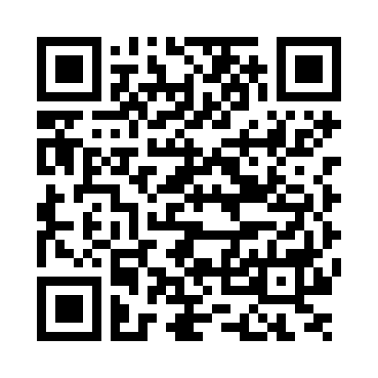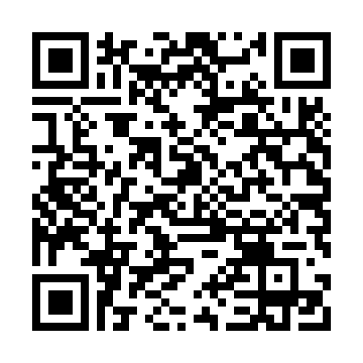
Android iPhone

Participants are encouraged to download the conference application (App) IAEA Conferences and Meetings, available at Google Play and the iTunes Store. The above QR codes will take you right there.

Once you have installed the App simply select this conference.

Log in!
Many of the App features can be accessed without logging in. However to enjoy all the features of the App you will need to log in with your individual event code. This code will be emailed to all registered participants approximately one week before the conference.

App Features
The App has a number of very useful features. Inter alia it allows you to:
- access both oral and poster synopses
- message comments or questions during discussion time
- message other participants
- view the up-to-date programme
- view the list of participants
- receive announcements via push notifications
- view ppt presentations of those speakers who have permitted their release, after the presentation.
- provide feedback on the conference using the evaluation form available on the App.

Should you have questions concerning the App please see the Conference Desk (at the conference).

