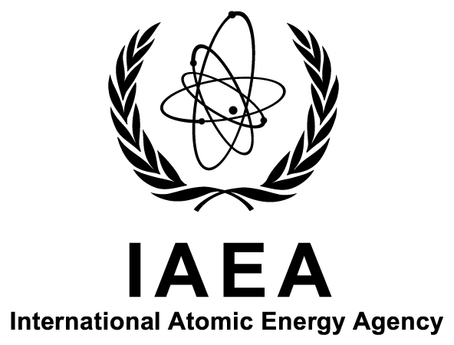

Department of Nuclear Sciences and Applications

IAEA Environment Laboratories, Monaco and Seibersdorf

ALMERA Training Workshop on the Determination of Organically Bound Tritium in Food Samples Using Liquid Scintillation Counting

Ref: K4-TM-52136

Title: | ALMERA Training Workshop on the Determination of Organically Bound Tritium in Food Samples Using Liquid Scintillation Counting
Host Institute: | Canadian Nuclear Safety Commission, Ottawa, Canada
Dates: | 26–30 September 2016
Deadline for Nominations: | 13 July 2016
Organizers: | The International Atomic Energy Agency (IAEA) and the Canadian Nuclear Safety Commission (CNSC), Canada
Host Country Organizer: | Mr Said Hamlat  Canadian Nuclear Safety Commission  280 Slater Street, P.O. Box 1046, Station B  OTTAWA, ON K1P 5S9  CANADA  Email: said.hamlat@canada.ca
Language: | English
Background Information: | ALMERA (‘Analytical Laboratories for the Measurement of Environmental Radioactivity’) is a worldwide network of analytical laboratories, established by the IAEA. Through methodological and data quality support received from the IAEA and collaborative method development and validation, ALMERA member laboratories are able to provide internationally acceptable radioanalytical data in normal situations as well as in case of accidental or intentional releases of radioactivity, as requested by their nominating authorities.  The course has been designed in response to the interest expressed by ALMERA laboratories to be trained in carrying out state-of-the-art radioanalytical procedures for enhancement of their environmental radioactivity measurement capabilities. It is part of the specific support provided to the laboratories, which includes methodological developments, proficiency tests and targeted training.
Purpose: | The course addresses the needs of ALMERA network laboratories interested in enhancing their environmental radioactivity monitoring programme. The purpose of the workshop is to provide participants with intensive training on the determination of organically bound tritium in food samples.
Expected Output(s): | The course will enable the participants to learn about a state-of-the-art method which they will be able to apply in their laboratories as part of their environmental radioactivity monitoring programme. The course will result in capacity building, dissemination of the method and harmonization amongst ALMERA laboratories.
Scope and  Nature: | The course will take place over a one-week period, providing laboratory practical work and lectures on the method. Laboratory safety instruction will be provided in preparation of laboratory work. Course materials will be also provided.  Over the one-week period the participants will perform within a radiochemical laboratory the determination of organically bound tritium in food samples using liquid scintillation counting, and will be trained on the calculation and uncertainty estimation of the measured activities.
Participation: | The course is open to 15 participants from laboratories that are members of the ALMERA network. Priority will be given to those laboratories which have expressed their interest in participating in methodological and analytical activities related to environment and food radioactivity monitoring and for which the measurement of organically bound tritium in food samples is of particular importance. Participants will be selected on the basis of their qualifications and using a competitive selection approach. Participants must be involved with environmental radioactivity measurement activities in their laboratories.  The ALMERA network has laboratories in the following IAEA Member States:  Argentina, Australia, Austria, Bangladesh, Belarus, Belgium, Bosnia and Herzegovina, Brazil, Bulgaria, Canada, Chile, China, Costa Rica, Croatia, Cuba, Cyprus, Czech Republic, Denmark, Egypt, Estonia, Ethiopia, Finland, France, Germany, Greece, Hungary, Iceland, India, Indonesia, Islamic Republic of Iran, Iraq, Ireland, Italy, Jamaica, Japan, Jordan, Kazakhstan, Kenya, Kuwait, Latvia, Lebanon, Lithuania, Luxembourg, The Former Yugoslav Republic of Macedonia, Madagascar, Malaysia, Malta, Mexico, Mongolia, Montenegro, Morocco, Myanmar, Netherlands, New Zealand, Norway, Pakistan, Panama, Peru, Philippines, Poland, Portugal, Qatar, Republic of Korea, Romania, Russian Federation, Saudi Arabia, Serbia, Singapore, Slovakia, Slovenia, South Africa, Spain, Sri Lanka, Sweden, Switzerland, Syrian Arab Republic, Thailand, Tunisia, Turkey, Ukraine, United Arab Emirates, United Kingdom, United States of America, Uruguay, Bolivarian Republic of Venezuela, and Zambia.
Participants’ Qualifications: | The participants should have a radiochemistry background and be involved in the measurement of radionuclides, in particular tritium, as part of an environmental radioactivity monitoring programme. The participants should hold a university degree and should have a minimum of two years’ experience in the above mentioned fields.
Nomination Procedure: | Nominations should be submitted to the IAEA using the attached Participation Form (Form A). The completed form should be endorsed by relevant national authorities and returned to the IAEA through the established official channels, i.e. the designated National Liaison Office for IAEA Matters.  The completed Participation Forms should reach the IAEA not later than 13 July 2016. Nominations received after this date or which have not been routed through the established official channels cannot be considered. Prospective participants are encouraged to send advance nominations to the Scientific Secretary of the workshop, Mr Aurélien Pitois, by email: A.Pitois@iaea.org, with a copy to the Administrative Secretary for the workshop, Ms Barbara Massinger (E-mail: B.Massinger@iaea.org).
Administrative and Financial Arrangements: | The organizers of the course do not accept liability for the payment of any cost or compensation that may arise from damage to or loss of personal property, or from illness, injury, disability or death of a participant while he/she is travelling to and from or attending the course, and it is clearly understood that each Government, in nominating participants, undertakes responsibility for such coverage. Governments would be well advised to take out insurance against these risks. A copy of the insurance policy will be requested for the issuance of the visa.

