IPET 2015
5-9 October 2015

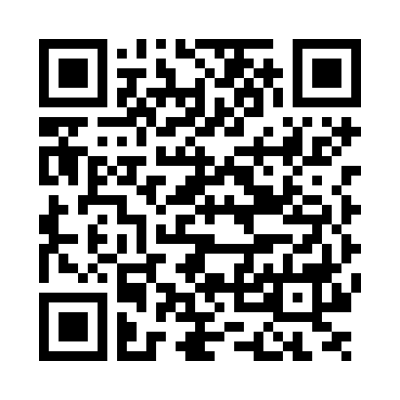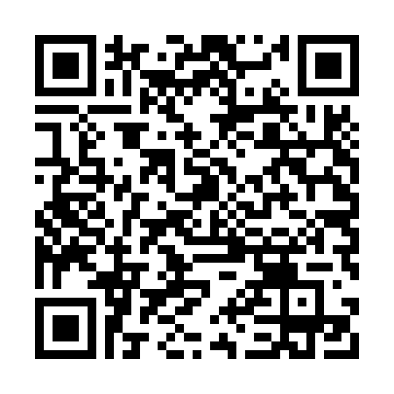
Android iPhone

Mobile Conference Application:
(for smart phones and tablets)

Participants are encouraged to download the conference application (App) IAEA Events, available at Google Play and the iTunes Store.

Once downloaded, simply go to the IPET 2015 Conference.

The App has a number of very useful features. Inter alia it allows you to:
- cast a vote at the Read-with-the Expert sessions;
- message comments or questions during discussion time;
- message other participants
- access powerpoint presentations and abstracts of posters
- view up-to-date programme
- receive announcements via push notifications

If you have questions or require assistance with the App, please contact the Conference Registration Desk, situated on the ground floor of the M Building.

