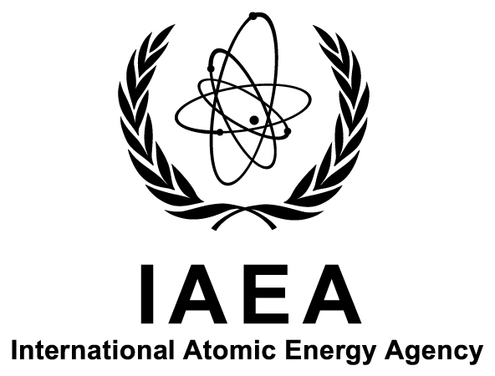

International Symposium on
Isotope Hydrology:

Revisiting Foundations and Exploring Frontiers

IAEA Headquarters
Vienna, Austria

11–15 May 2015

Ref. No: IAEA-CN-225

Announcement and Call for Papers

Introduction
The International Atomic Energy Agency (IAEA) has convened quadrennial symposia on isotope hydrology since 1963. For more than 50 years, these IAEA symposia have provided a unique opportunity to review the state-of-the-science, practical applications, and research trends and needs in isotope hydrology, leading to its recognition as a discipline in its own right within the science of hydrology. Isotope hydrology contributes to a better understanding of the water cycle and has applications in water resources assessment and management, the study of past and future changes in the Earth’s climate as well as of climate impacts on the water cycle, and in forensic areas such as ecological, wildlife and food source traceability.
This is the 14th symposium in the series and it will be held at the IAEA’s Headquarters in Vienna, Austria, from 11 to 15 May 2015. The symposium will aim to facilitate the exchange of information and knowledge among water and environment professionals from developed and developing countries.

Objectives
The objectives of the symposium are to: (a) review and revisit the foundational principles of isotope hydrology in the light of the current state of knowledge; (b) review recent developments in analytical instrumentation and applications of isotopes in water and climate studies; and (c) identify research, analytical and training requirements for a wider use of isotope hydrology.

List of Topics
- Isotopes in hydrosphere–atmosphere interactions and palaeoclimate reconstruction
- Groundwater dating and palaeohydrology
- Water balance and hydrological processes
- How laser spectroscopy is transforming isotope research
- New approaches and tools in isotope science
- Water scarcity, water quality, food security, climate change, and energy resources

Target Audience
The symposium is aimed at professionals involved in a broad spectrum of disciplines, including: water resources management, processes in the hydrosphere and atmosphere, climate change and its impact on the water cycle, environmental modelling, protection of the environment, geographical information systems, emergency response, and the development of isotopic techniques and tools. Government officials, including policymakers and individuals responsible for the assessment of environmental programmes, would also benefit from attending the symposium.

Working Language
The working language of the symposium will be English.

Structure
The opening session will include welcoming addresses by representatives of the IAEA and cooperating organizations as well as the first keynote presentation.
A series of plenary sessions will address the topics mentioned in Section C. Each session will consist of:
- Invited keynote paper(s);
- Oral presentations;
- Panel discussion.
Poster sessions will be organized for all accepted papers and will include ample time for discussion and interaction with colleagues.
A final round-table session will include presentations by the session chairpersons of the main conclusions drawn in their respective sessions and of the recommendations for the future development of international cooperation, including IAEA activities.
It is being considered to devote one day of the symposium to a field trip which will highlight the geology and hydrogeology of the Vienna Basin.

Papers and Posters
Contributions on the topics listed in Section C covering isotope applications relevant to water resources management and climate studies are welcome as oral or poster presentations. All papers submitted — other than invited keynote papers — must present original work and should not have been published elsewhere. Poster sessions will be used to promote greater interactions among symposium participants. A Book of Synopses of the accepted contributions will be distributed to all participants at the opening of the symposium.

Submission of Synopses
Synopses (up to four printed A4 pages, including figures and references) must be uploaded to the symposium’s web browser-based file submission system (IAEA-INDICO) which will be available on the symposium web page (see Section O) until 15 November 2014. No other submission route will be accepted. Specifications for the layout will be available on INDICO.
In addition, all participants must submit the following two forms to their appropriate governmental authority (see Section H) for transmission to the IAEA. These forms must be received by the IAEA no later than 15 November 2014.
- Participation Form (Form A)
- Form for Submission of a Paper (Form B)
IMPORTANT: The uploaded synopses will be considered by the Programme Committee only if these two forms have been received by the IAEA through the established official channels (see Section H).

Acceptance of Synopses
Authors will be informed by 16 January 2015 as to whether their synopses have been accepted for inclusion in the Book of Synopses and, as appropriate, for ultimate presentation in an oral or a poster session and will receive further guidelines. The IAEA, however, reserves the right to refuse the presentation or publication of any submission that does not meet expectations based on the information given in the synopses.
IMPORTANT: The system for electronic submission of papers, IAEA-INDICO, is the sole mechanism for submission of the synopses. Authors are encouraged to submit the synopses as early as possible.

Participation and Registration
No registration fee is charged to participants.
All persons wishing to participate in the symposium are requested to register online in advance through the symposium web page. In addition, they must send a completed
- Participation Form (Form A)
- Form for Submission of a Paper (Form B), (if applicable)
- Grant Application Form (Form C), (if applicable)
as soon as possible to the competent official authority:
- Ministry of Foreign Affairs or
- National Atomic Energy Authority
or to one of the organizations invited to participate for subsequent electronic transmission to the IAEA (Official.Mail@iaea.org).
A participant will be accepted only if the Participation Form is transmitted through the competent official authority of a Member State of the IAEA or by an organization invited to participate.
Participants whose official designations have been received by the IAEA will receive further information on the symposium at least three months before the opening of the symposium. This information will also be posted on the symposium web page (see Section O).

Expenditures and Grants
The IAEA is generally not in a position to bear the travel and other costs of participants in the symposium. The IAEA has, however, limited funds at its disposal to help meet the cost of attendance of certain participants. Such assistance may be offered upon specific request to normally one participant per country provided that, in the IAEA’s view, the participant on whose behalf assistance is requested will make an important contribution to the symposium.
If Governments wish to apply for a grant on behalf of one of their specialists, they should address specific requests to the IAEA to this effect. Governments should ensure that applications for grants are:
1. Submitted by 15 November 2014;
2. Accompanied by a completed and signed Grant Application Form (Form C); and
3. Accompanied by a completed Participation Form (Form A).
Applications that do not comply with the above conditions cannot be considered.
Approved grants will be issued in the form of a lump sum payment that usually covers only part of the cost of attendance.

Venue and Accommodation
The symposium will be held at the IAEA’s Headquarters in Vienna, Austria. Participants must make their own travel and accommodation arrangements. Detailed information on accommodation and other relevant matters will be sent directly to all designated participants approximately three months before the opening of the symposium. This information will also be made available on the symposium web page (see Section O) as soon as possible.

Visas
Designated participants who require a visa to enter Austria should submit the necessary application to the nearest diplomatic or consular representative of Austria at least four weeks before they travel to Austria. Since Austria is a Schengen State, persons requiring a visa will have to apply for a Schengen visa. In States where Austria has no diplomatic mission, visas can be obtained from the consular authority of a Schengen Partner State representing Austria in the country in question.

Key Deadlines and Dates
Submission of Form for Submission of a Paper (Form B) and synopsis: 15 November 2014
Submission of Grant Application Form (Form C): 15 November 2014
Notification of acceptance of papers: 16 January 2015

Exhibits
A limited amount of space will be available for commercial vendors’ displays/exhibits during the symposium. Interested parties should contact the Scientific Secretariat by email:
Isotope-Hydrology-Symposium-2015@iaea.org before 31 October 2014.

Symposium Secretariat
General contact details:
International Atomic Energy Agency
Vienna International Centre
PO Box 100
1400 VIENNA
AUSTRIA
Tel.: +43 1 2600
Fax: +43 1 2600 2007
Email: Official.Mail@iaea.org

Scientific Secretary:
Mr Luis J. Araguás Araguás
Isotope Hydrology Section
Division of Physical and Chemical Sciences
Department of Nuclear Sciences and Applications
Tel.: +43 1 2600 21734
Email: Isotope-Hydrology-Symposium-2015@iaea.org

Administration and organization:
Ms Martina Khaelss
Conference Services Section
Division of Conference and Document Services
Department of Management
IAEA-CN-225
Tel.: +43 1 2600 21315
Email: M.Khaelss@iaea.org
Subsequent correspondence on scientific matters should be sent to the Scientific Secretary and correspondence on administrative matters to the IAEA’s Conference Services Section.

Symposium Web Page
Please visit the IAEA symposium web page regularly for new information regarding this symposium:
http://www-pub.iaea.org/iaeameetings/46527/Isotope-Hydrology-Symposium-2015

