How to Write and Submit a Synopsis to the EPR Conference 2015

E. BUGLOVA
International Atomic Energy Agency, Incident and Emergency Centre, P.O. Box 100, Vienna, Austria
E-mail address: E.Buglova@iaea.org
R. MARTINCIC, J. ZELLINGER
International Atomic Energy Agency, Incident and Emergency Centre, P.O. Box 100, Vienna, Austria
Abstract: abstracts covering various areas of emergency preparedness and response to nuclear or radiological emergency are welcome, and may be requested for an oral or poster presentation, and in a specific conference topic. All papers submitted – other than invited keynote papers – must present original work and should not have been published elsewhere.
Where the number of oral requests exceeds slots available, the International Conference Programme Committee will assign papers to an appropriate poster session. A Book of Synopses of accepted contributions will be made available online about one week before the opening of the conference. It will also be available electronically and free of charge upon registration at the conference.

1. Introduction
Any participant wishing to present a paper during the conference must submit synopsis directly to the IAEA using the conference’s web browser-based file submission system INDICO. No other form of submission will be accepted.
The paper should be divided into 1. Introduction, 2. Method, 3. Results, and 4. Conclusions or an equivalent division.

2. Method
The first step in submission requires creation of a user account on the INDICO conference system, using the 'Login' tab in the top right corner of the page. If you are already a registered INDICO user, please log into the system.
The first step in the submission process is the creation of an account in the INDICO system. Use the orange 'Login' tab in the top right corner of the page to create an account or, if you already have an account, to log in to the system.
If you already have an INDICO account but have forgotten your password, please use the corresponding link provided under the "Login" tab to have your INDICO credentials sent to you by email.
Once users have logged in, they can submit a synopsis via the "Submit a New Synopsis" link on the left-hand navigation panel.

Authors must type or copy the title and abstract from their synopsis within the space provided, whilst synopses themselves must be uploaded as an attachment in MS Word format using the "attach a file" function also provided under the "Submit a New Synopsis" link.

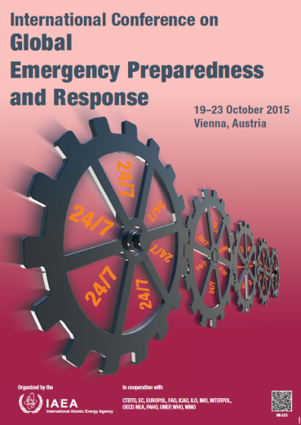
Conference poster is shown in Figure 1.

Figure 1. EPR Conference 2015 poster.

3. Results
The synopsis must be submitted through this system no later than 17 April 2015.
The electronically received synopsis will be considered by the International Conference Programme Committee. Authors will be notified via email by 26 June 2015 as to whether their contributions have been accepted for oral or poster presentation.
The results are tabulated in Table 1 as shown below:
Table 1. Programme Committee results.
Author | Contribution | Value (P) | Result
R. Martincic | Poster | 10.9±0.2 | Accepted
E. Buglova | Oral | 54.3±1.0 | Accepted
J. Zellinger | Oral | <20.1 | Accepted as poster
All papers will be available in pdf format, with the author’s permissions, on the conference web page after the conference. Authors need to provide the release right on the Form B “Form for Submission of a Paper’.

4. Conclusions
All citations should be indicated with consecutive numbers in brackets within the main body of the text i.e. [1] and must follow the IAEA citation style as shown below.
The maximum length of synopsis is 4 pages including figures and tables. Minimum length is 500 words.
References
[1] STEPHENSON, R., Introduction to Nuclear Engineering, 2nd edn, McGraw-Hill, New York (1958) 491 pp.
[2] GEYH, M.A., Messungen der Tritium-Konzentration in Salzlaugen, Kali Steinsalz 5 (1969) 208.
[3] INTERNATIONAL COMMISSION ON RADIOLOGICAL PROTECTION, Evaluation of Radiation Doses to Body Tissues from Internal Contamination due to Occupational Exposure, Publication 10, Pergamon Press, Oxford and New York (1968).
[4] GUTHRIE, F.E., PERRY, J.J. (Eds), Introduction to Environmental Toxicology, Blackwell, Oxford (1980).
[5] HOWLAND, G.P., HART, R.W., “Radiation biology of cultured plant cells”, Applied and Fundamental Aspects of Plant Cell, Tissue, and Organ Culture, 2nd edn (REINERT, J., BAJAJ, Y.R.S., Eds), Springer-Verlag, Berlin (in press).
[6] BURKE, S.D., HOWELL, J.P., “Impact of prolonged wet storage of DOE reactor irradiated nuclear materials at the Savannah River Site”, Proc. Topical Mtg on DOE Spent Nuclear Fuel — Challenges and Initiatives, Salt Lake City, 1994, USDOE, Washington, DC (1994) 118–124.
[7] COCHRANE, M.P., DUFFS, C.M., Endosperm cell number in barley, Nature 289 (1981) 399.
[8] BLOUNT, E.I., Symmetry properties of triplet superconductors, Phys. Rev., B: Condens. Matter 32 (1985) 2935.
[9] TEPPER, L., Suboptimal control study of a nuclear power plant, IEEE Trans. Nucl. Sci. NS-22 (1975) 812.
[10] PEACOCK, K.L., Design of discrete bandpass filters for petroleum exploration, Oil Gas J. 83 (1985) 121.

