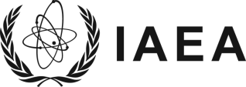
Atoms for Peace
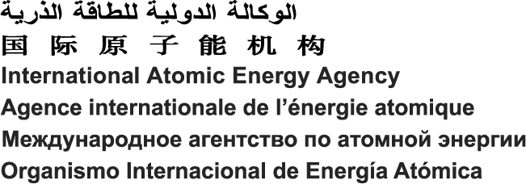
M-12/Rev. 8 (Sept 09)

Vienna International Centre, PO Box 100, 1400 Vienna, Austria
Phone: (+43 1) 2600 • Fax: (+43 1) 26007
Email: Official.Mail@iaea.org • Internet: http://www.iaea.org

In reply please refer to: J20-TR-50896
Dial directly to extension: (+431) 2600-21956

The Secretariat of the International Atomic Energy Agency (IAEA) presents its compliments to the Ministries of Foreign Affairs of the IAEA’s Member States and has the honour to request that they draw the attention of the appropriate governmental authorities to the forthcoming Workshop on Best Practices in Physics-Based Fault Rupture Models for Seismic Hazard Assessment of Nuclear Installations to be held at the IAEA’s Headquarters in Vienna, Austria, from 18 to 20 November 2015.
The purpose of the workshop is to discuss the applicability of physics-based fault rupture models to generate synthetic earthquake ground motions for use in the seismic hazard assessment of nuclear installations.
The attached Information Sheet provides further details of the workshop.
The workshop will be held in English.
Member States are invited to nominate one or more participants for this workshop. Member States are strongly encouraged to identify suitable women participants.
The IAEA is generally not in a position to bear the travel and other costs of participants in the workshop.
It should be noted that compensation is not payable by the IAEA for any damage to or loss of personal property. The IAEA also does not provide health insurance coverage for participants in meetings, workshops or training courses or for consultants. Arrangements for private insurance coverage on an individual basis should therefore be made. The IAEA will, however, provide insurance coverage for accidents and illnesses that clearly result from any work performed for the IAEA.
Nominations should be submitted through the established official channels not later than 10 September 2015 for the attention of the Scientific Secretary of the workshop, Mr Yoshimitsu Fukushima, Division of Nuclear Installation Safety, Department of Nuclear Safety and Security, IAEA, Vienna International Centre, PO Box 100, 1400 Vienna, Austria (Tel.: +43 1 2600 21956; Fax: +43 1 26007; Email: Y.Fukushima@iaea.org). The full names and complete contact details (including postal address, telephone/fax numbers, and email address) of nominated participants should be provided.
The Secretariat of the International Atomic Energy Agency avails itself of this opportunity to assure the Ministries of Foreign Affairs of the IAEA’s Member States of its highest consideration.
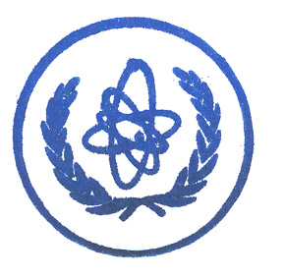
2015-06-16

Enclosures: Information Sheet
Participation Form (Form A)

