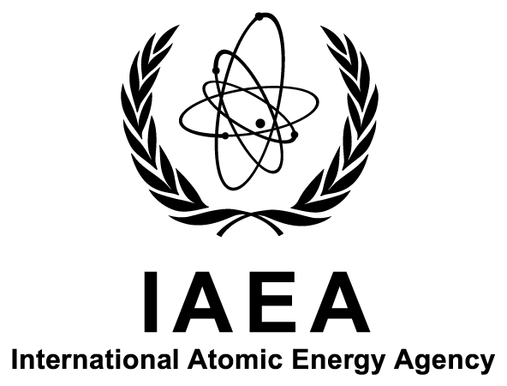

Technical Meeting on the
Development of Nuclear Instrumentation for
In Situ Environmental Monitoring Programmes

IAEA Headquarters
Vienna, Austria

30 November–4 December 2015

Ref. No.: F1-TM-49618

Information Sheet

Background
Radiologically contaminated sites exist and persist all over the world. Such sites may expose the general public to ionizing radiation, potentially leading to negative health effects in the exposed population.
Originating from nuclear and/or radiological accidents, or created in connection with past activities that were regulated (though not in accordance with prevailing international standards) or that were never under regulatory control, information on these sites can range from highly detailed (e.g. inventories) to vague (e.g. unexpected observations of higher than background dose rates).
The International Atomic Energy Agency (IAEA) would like to see its Member States succeed in establishing proper, sufficient infrastructure and technologies for the radiological characterization of contaminated sites in a timely, safe and cost-effective manner.
Aligned with this vision, the INSITU Working Group was created within the Network on Environmental Management and Remediation (ENVIRONET), with the aim of facilitating and increasing the exchange of information and experiences within the specific field of in situ methods for site characterization. The ultimate goal of this group is to build capacity in the different IAEA Member States and to facilitate the full implementation of remediation projects.
This meeting is being organized to highlight, review and discuss issues related to the current status of nuclear instrumentation for in situ environmental monitoring applications, including practical guidelines for its effective utilization in developing Member States. The following topics are expected to be included in the programme:
- State-of-the-art nuclear instrumentation for environmental monitoring, including analytical methodologies;
- How to ensure the effective operation, maintenance and repair of state-of-the-art instrumentation used for environmental studies;
- Practical training in the operation and effective utilization of nuclear instrumentation for environmental applications, including the development of conventional and e-learning tools;
- Tools and methodologies for meaningful in situ characterization;
- Quality control/assurance for nuclear instrumentation and analytical methodologies;
- Role of national and international networks, including specifically ENVIRONET and the INSITU Working Group;
- Role of the IAEA in providing support for the activities undertaken by developing Member States to effectively apply nuclear instrumentation for environmental monitoring.

Objectives
The purpose of the meeting is to review international experience in the conduct of in situ radiological site characterizations in order to disseminate best practices and novel methodologies and update the community on the latest technological possibilities. Opportunities for collaboration and the possible role of the IAEA will be explored, and a report reflecting on the progress achieved in this field (with respect to in situ characterization) will be prepared.
The meeting will result in a report and guidelines for the effective utilization of nuclear instrumentation for in situ environmental monitoring in developing Member States, including technical and managerial requirements and a consideration of the possible role of the IAEA.

Participation
A person will be eligible to participate only if nominated by the Government of an IAEA Member State (Ministry of Foreign Affairs or National Atomic Energy Authority) or by an organization invited to participate. Nominations should be submitted using the attached Participation Form (Form A) and must be received by the IAEA not later than 17 July 2015.
Nominated participants should be:
- In the case of presenting intercomparison results, the responsible analyst;
or
- Interested in participating within ENVIRONET’s INSITU Working Group. The participant should preferably be already registered with ENVIRONET and be a user of nuclear instrumentation or a manager in the field of environmental applications of nuclear and related analytical techniques.
Applicants fulfilling both or either of the above criteria will be given preference for participation
A contribution from the participant in the form of a short abstract covering his/her work relevant to the objectives of the meeting will be necessary for consideration for participation, including his/her motivation for participation in the INSITU Working Group.
The abstract should be prepared according to the following instructions:
- Page size: A4 (21 cm by 29.7 cm) — vertical orientation
- Margins: 25 mm all around
- Layout:
  - Title: single-spaced, 14-point size, Times New Roman (TNR) font, bold
  - Authors: single-spaced, 12-point size, TNR font
  - Affiliation: single-spaced, 12-point size, TNR font, italics
  - Text: 1.5 spaced, 12-point size, TNR font
  - Length: one page
Important: In case of sending Microsoft Word files, authors should use True Type Embedded Fonts (when saving the file, click Tools, then Options, and tick Embed True Type fonts. This will help to prevent change of fonts when the file is read in a different system, as is expected in most of the cases). PDF files are preferred.

Financial Support
The IAEA is generally not in a position to bear the travel and other costs of participants in the meeting. The IAEA has, however, limited funds at its disposal to help meet the cost of attendance of certain participants. Such assistance may be offered upon specific request to normally one participant per country provided that, in the IAEA’s view, the participant on whose behalf assistance is requested will make an important contribution to the meeting. The application for financial support — using the attached Grant Application Form (Form C) — should be made at the time of nominating the participant.

Meeting Format
To facilitate proceedings, participants are invited to contribute an oral presentation on subject relevant to the scope and objectives of this meeting. Participants should submit an abstract of their proposed presentation along with their nomination. The official language of the meeting is English. No interpretation will be provided.
The meeting is scheduled to start at 13:00 on Monday, 30 November 2015, and is expected to conclude by 12:00 on Friday, 4 December 2015.
The outputs of discussions will be recorded for possible dissemination to Member States as an IAEA technical publication. Contributors of material to be included in the proceedings are required to assign all copyrights or rights to publish to the IAEA. Please complete and sign the attached Form for Submission of a Paper (Form B) and send it to the IAEA Scientific Secretary (see Section I below) by fax or email. The authors should ensure that material they make available for possible publication by the IAEA does not include copyrighted material or other impediments for reproduction.

Local Arrangements
It is the responsibility of all participants to make their own travel arrangements to/from Austria. Detailed information on accommodation, local transport to/from the meeting venue, and other organizational details, will be sent to all participants well in advance of the meeting.

Visas
Participants who require a visa to enter Austria should submit the necessary application to the nearest diplomatic or consular representative of Austria well in advance of entry. An official letter of invitation will be issued to all participants by the IAEA Scientific Secretary.

Key Dates (Revised)
- 11 September 2015: Deadline for submission of requests to the IAEA for participation and financial support
- 16 October 2015: Nominees are informed as to whether or not they have been accepted for participation, as well as of the outcome of their requests for financial support.

Organization
Scientific Secretary:
Mr Iain Darby
Nuclear Science and Instrumentation Laboratory
Physics Section
Division of Physical and Chemical Sciences
Department of Nuclear Sciences and Applications
International Atomic Energy Agency
Vienna International Centre
PO Box 100
1400 VIENNA
AUSTRIA

Tel.: +43 1 2600 28622
Fax: +43 1 2600 28222
Email: TM49618@iaea.org

Administrative Secretary:
Ms Anna Naftaliev
Nuclear Science and Instrumentation Laboratory
Physics Section
Division of Physical and Chemical Sciences
Department of Nuclear Sciences and Applications
International Atomic Energy Agency
Vienna International Centre
PO Box 100
1400 VIENNA
AUSTRIA

Tel.: +43 1 2600 28227
Fax: +43 1 2600 28222
Email: TM49618@iaea.org

Subsequent correspondence on scientific matters should be sent to the Scientific Secretary and correspondence on other matters related to the meeting to the Administrative Secretary.

See: http://www.iaea.org/OurWork/ST/NE/NEFW/WTS-Networks/ENVIRONET/overview.html.

