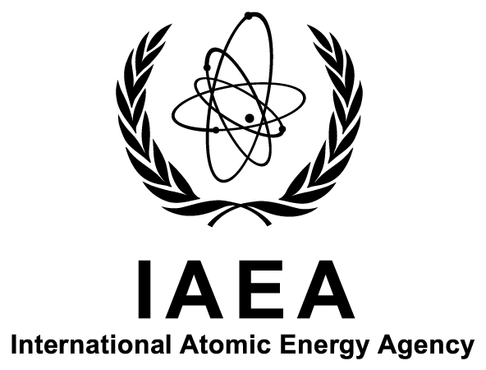

International Atomic Energy Agency

Department of Nuclear Sciences and Applications

IAEA Environment Laboratories

Monaco and Seibersdorf

Analytical Laboratories for the Measurement of Environmental Radioactivity

A L M E R A

Practical Training Course on Rapid Determination of Radiostrontium in Milk Using Cerenkov and Scintillation Counting

Ref: IAEA-TM-47506

Prospectus

Title: | ALMERA Practical Training Course on Rapid Determination of Radiostrontium in Milk Using Cerenkov and Scintillation Counting
Host Institute: | Korea Institute of Nuclear Safety, Daejeon, Republic of Korea
Dates: | 3–7 November 2014
Deadline for Nominations: | 1 August 2014
Organizers: | The International Atomic Energy Agency (IAEA) and the Korea Institute of Nuclear Safety (KINS), Republic of Korea
Host Country Organizer: | Mr Cheolsu Kim  Korea Institute of Nuclear Safety  19 Gusung, Yuseong  DAEJEON, 305-338  REPUBLIC OF KOREA  Email: cskim@kins.re.kr
Language: | English
Purpose: | The course addresses the needs of ALMERA network laboratories interested in enhancing their rapid analytical capabilities supporting the assessment of environmental and food contamination in emergency situations. The purpose of the course is to provide participants with intensive training on a rapid radiochemical laboratory procedure validated by ALMERA laboratories and published by the IAEA for the determination of radiostrontium in milk.
Expected Output(s): | The course will enable the participants to learn about a state-of-the-art method which they will apply in their laboratories in situations where a rapid assessment of radionuclides in the environment and the food chain is required. The course will result in dissemination of this method and harmonization amongst ALMERA laboratories.
Scope and  Nature: | The course will take place over a one-week period, providing laboratory practical work and lectures on the method. Laboratory safety instruction will be provided in preparation of laboratory work.  Course materials and, where applicable, IAEA documents, will be provided  Over the one-week period the participants will perform within a radiochemical laboratory the rapid determination of radiostrontium in milk using Cerenkov and scintillation counting, and will be trained on the calculation and uncertainty estimation of the measured activities.
Background Information: | The course has been designed in response to the interest expressed by many ALMERA laboratories in developing their rapid assessment capabilities. It is part of the specific support provided to these laboratories, which includes methodological developments, proficiency tests and targeted training.
Participation: | The course is open to 12 participants from laboratories that are members of the ALMERA network. Priority will be given to those laboratories which have expressed their interest in developing their rapid response capabilities and in participating in related methodological, analytical and preparedness activities. Participants will be selected on the basis of their qualifications and using a competitive selection approach. Participants must be involved with rapid assessment activities in their laboratories.  The ALMERA network has laboratories in the following IAEA Member States:  Argentina, Australia, Austria, Bangladesh, Belarus, Belgium, Bosnia and Herzegovina, Brazil, Bulgaria, Canada, Chile, China, Costa Rica, Croatia, Cuba, Cyprus, Czech Republic, Denmark, Egypt, Estonia, Ethiopia, Finland, France, Germany, Greece, Hungary, Iceland, India, Indonesia, Islamic Republic of Iran, Iraq, Ireland, Italy, Jamaica, Japan, Jordan, Kazakhstan, Kenya, Kuwait, Latvia, Lebanon, Lithuania, Luxembourg, Madagascar, Malaysia, Malta, Mexico, Mongolia, Montenegro, Morocco, Myanmar, Netherlands, New Zealand, Norway, Pakistan, Panama, Peru, Philippines, Poland, Portugal, Qatar, Republic of Korea, Romania, Russian Federation, Saudi Arabia, Serbia, Slovakia, Slovenia, South Africa, Spain, Sri Lanka, Sweden, Switzerland, Syrian Arab Republic, Thailand, Tunisia, Turkey, Ukraine, United Arab Emirates, United Kingdom, United States of America, Uruguay, Bolivarian Republic of Venezuela, and Zambia.
Participants’ Qualifications: | The participants should be specialists in environmental radiochemistry and radioanalytical techniques. The participants should hold a university degree and should have a minimum of two years’ experience in the above-mentioned fields.
Nomination Procedure: | Nominations should be submitted to the IAEA using the attached Participation Form (Form A). The completed form should be endorsed by relevant national authorities and returned to the IAEA through the established official channels, i.e. the designated National Liaison Office for IAEA Matters.  The completed Participation Forms should reach the IAEA not later than 1 August 2014. Nominations received after this date or which have not been routed through the established official channels cannot be considered. Prospective participants are encouraged to send advance nominations to the Scientific Secretary of the course, Mr Aurélien Pitois, by email: A.Pitois@iaea.org, with a copy to the Administrative Secretary for the course, Ms Karin Will (Email: K.Will@iaea.org).
Administrative and Financial Arrangements: | The organizers of the course do not accept liability for the payment of any cost or compensation that may arise from damage to or loss of personal property, or from illness, injury, disability or death of a participant while he/she is travelling to and from or attending the course, and it is clearly understood that each Government, in nominating participants, undertakes responsibility for such coverage. Governments would be well advised to take out insurance against these risks. A copy of the insurance policy will be requested for the issuance of the visa.

