FORM A
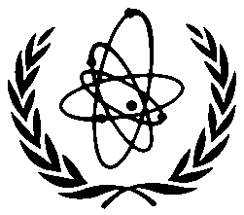

INTERNATIONAL ATOMIC ENERGY AGENCY (IAEA)

Plenary Meeting of the
International Seismic Safety Centre’s Programme

IAEA Headquarters
Vienna, Austria

27 to 31 January 2014

To be sent to the competent official authority (Ministry of Foreign Affairs or National Atomic Energy Authority) for transmission to: Mr Yasunori Noguchi, International Seismic Safety Centre, Department of Nuclear Safety and Security, IAEA, Vienna International Centre, PO Box 100, 1400 Vienna, Austria (Fax: +43 1 26007; Email: Y.Noguchi@iaea.org)

PARTICIPATION FORM
Deadline for receipt by IAEA through official channels: 13 December 2013
Family name: |  | All initials of given name: | Mr  Ms
Institution: |  | Full address:
For urgent communications please indicate:
Phone:
Fax:
Email:
Nationality: | Nominating Government:
Mailing address (if different from address of institution):

Do you intend to present a paper? YES □ NO □
Title of the paper:
An abstract of the paper (500 words) is attached? YES □ NO □

