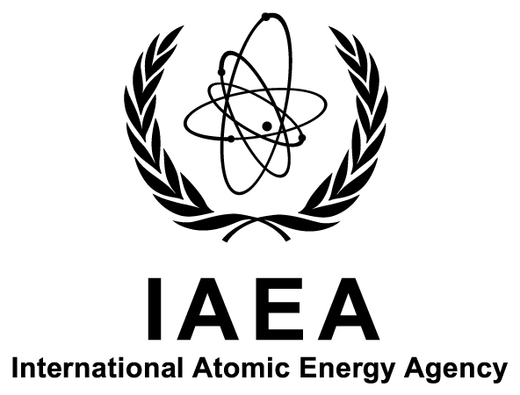

11th Coordination Meeting of the IAEA’s Network of Analytical Laboratories for the Measurement of Environmental Radioactivity (ALMERA)

IAEA Headquarters
Vienna, Austria

7–10 October 2014

Ref. No: K4-TM-47065

Information Sheet

Background
ALMERA (Analytical Laboratories for the Measurement of Environmental Radioactivity) is a worldwide network of analytical laboratories, established by the International Atomic Energy Agency (IAEA) in 1995. Through methodological and data quality support received from the IAEA and collaborative method development and validation, ALMERA member laboratories are able to provide internationally acceptable radioanalytical data in normal situations as well as in cases of accidental or intentional release of radioactivity, as requested by their national authorities.
The ALMERA network holds annual coordination meetings to discuss the implementation of planned activities and to define future activities of the network.
Within this context, ALMERA laboratories representatives are invited to attend the 11th coordination meeting of the ALMERA network, to be held from 7 to 10 October 2014 at the IAEA Headquarters in Vienna, Austria.

Objectives
The purpose of the meeting is to review ALMERA activities and to define a future work plan for developing the network’s activities in the following areas: recommended radioanalytical methods, reference materials and proficiency testing, methodologies supporting routine and emergency environmental monitoring, and radioecological assessment.
The specific objectives of the meeting are to:
- Present and discuss ALMERA proficiency test results and related proposals;
- Discuss the current status and plans for recommended analytical procedures developed within the ALMERA network;
- Discuss priorities for training courses and workshops;
- Discuss means for communication and data sharing and exchange among ALMERA laboratories in emergency situations;
- Discuss initiatives for regional cooperation and collaboration with other networks;
- Identify work plans and proposals of the ALMERA regional groups and task groups; and
- Review and update the general ALMERA work plan.
The venue has been chosen so as to facilitate the involvement of specialists working in related fields across the IAEA to support exchange of information and collaboration with different programmes of the IAEA.

Scope and Format
The meeting will provide an opportunity to undertake, at the senior technical level, a thorough review of the work plan for future ALMERA activities. The meeting will also discuss how to increase the role of regional coordination centres in mobilizing the network’s experience, encouraging exchange of expertise and supporting capacity building at regional level.
The meeting will consist of a plenary session and working sessions for the network’s regional groups as well as its task groups. The plenary session will include presentations by ALMERA members on developments of radioanalytical methods, quality systems and relevant monitoring and assessment projects in their laboratories and presentations by IAEA specialists in relevant areas. The overall ALMERA work plan will be presented at the plenary session on 10 October 2014.

Participation
All ALMERA representatives wishing to attend the meeting should be nominated by their Government (Ministry of Foreign Affairs or National Atomic Energy Authority). Nominations for participation (using the attached Form A) should be received by the IAEA not later than 4 July 2014.
The final list of participants will be approved by 14 July 2014 and the confirmation of acceptance will be sent to the participants by the end of July.

Financial Support
Please be informed that attendance at the meeting is free of charge for ALMERA members. However, the costs of members’ participation can not be borne by the IAEA (accommodation, travel costs and all other expenses should be covered by participants’ institutes), with the exception of a limited number of grants, which will be made available to applicants from developing Member States.
The grant application (using the attached Form C) should be received by the IAEA no later than 4 July 2014. No grant application will be considered after this date.

Local Arrangements
It is the responsibility of all participants to make their own travel arrangements to/from Austria. Detailed information on accommodation, local transport to/from the meeting venue, and other organizational matters will be sent to all designated participants by the Administrative Secretary for the meeting (see Section H below).

Visas
Designated participants who require a visa to enter Austria should submit the necessary application to the nearest diplomatic or consular representative of Austria well in advance of entry. An official letter of invitation will be issued to all designated participants by the Administrative Secretary for the meeting.

Organization
Scientific Secretary:
Mr Aurélien Pitois
Terrestrial Environment Laboratory
IAEA Environment Laboratories
Department of Nuclear Sciences and Applications
International Atomic Energy Agency
Vienna International Centre
PO Box 100
1400 VIENNA
AUSTRIA

Tel.: +43 1 2600 28226
Fax: +43 1 26007
Email: A.Pitois@iaea.org

Administrative Secretary:
Ms Karin Will
Terrestrial Environment Laboratory
IAEA Environment Laboratories
Department of Nuclear Sciences and Applications
International Atomic Energy Agency
Vienna International Centre
PO Box 100
1400 VIENNA
AUSTRIA

Tel.: +43 1 2600 28237
Fax: +43 1 26007
Email: K.Will@iaea.org

Subsequent correspondence on scientific matters should be sent to the Scientific Secretary and correspondence on other matters related to the meeting to the Administrative Secretary.

