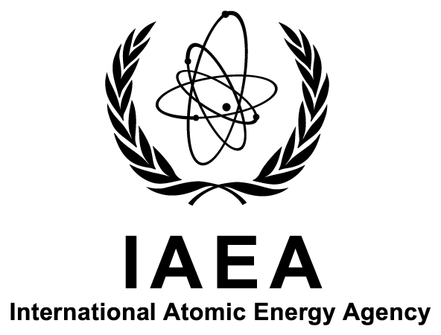

Technical Meeting on Stable Isotope Reference Materials

IAEA Headquarters
Vienna, Austria

1–5 September 2014

Ref. No: K4-TM-45739

Information Sheet

Background
Since the 1960s the International Atomic Energy Agency (IAEA) has produced and distributed international (primary, scale-defining) reference materials (RMs) for stable isotope measurements of the light elements hydrogen (H), boron (B), carbon (C), nitrogen (N), oxygen (O), sulphur (S) and chlorine (Cl). These RMs define isotope ratio scales for light elements. Stable isotope measurements are widely used for environmental studies, atmospheric monitoring, forensics, geology, life studies, etc. By using international RMs from the IAEA, isotope measurements are synchronized worldwide. The IAEA-developed RMs that are based on natural materials and chemicals (sea and precipitation waters, natural marble, carbonates, polyethylene, etc) should closely match the various samples under analysis both in terms of their isotope composition and chemical–physical forms, and they should also be tailored to the analytical methods being used. The development of new methods and new analytical techniques, in particular continuous flow analysis and optical techniques for stable isotope analysis, requires extending the range of RMs presently available. At the moment several new RMs and candidate RMs are under calibration. As the IAEA cannot hold all the instruments and methods available on the market, expert laboratories worldwide are involved in the calibration process.
Within this context, representatives of expert laboratories are invited to attend the Technical Meeting on Stable Isotope Reference Materials to be held from 1 to 5 September 2014, at the IAEA’s Headquarters in Vienna, Austria.

Objectives
The objective of the meeting is to identify the need for new RMs, their chemical–physical forms, packing and distribution as well as to discuss the ongoing calibration of new RMs and candidate RMs and preliminary results. The specific objectives include the following:
- To discuss the calibration of candidate RMs (several organic materials) for H-C-N isotope analyses by combustion/pyrolysis continuous flow techniques (including presentation and evaluation of the preliminary results);
- To present and evaluate results on RM IAEA-603 carbonate (replacement for the ¹³C-scale-defining RM NBS19, exhausted) and RMs in the form of environmental waters;
- To discuss metrological aspects of RM calibration and the uncertainty evaluation;
- To provide an overview of the IAEA’s capacities for stable isotope RM production and characterization as well as of latest developments, including the new mass spectrometry system installed in 2014; and
- To identify future needs in stable isotope RMs related to new methods and new measurement techniques, define critical applications (e.g. atmospheric and environmental monitoring), set priorities and outline the strategic plan for stable isotope RMs at the IAEA.
The venue has been chosen in order to facilitate the involvement of specialists working in related fields outside the IAEA, to support the exchange of information and collaboration with external expert laboratories, and to optimize the IAEA’s activities in addressing Member States’ needs.

Scope and Format
The meeting will provide an opportunity to meet representatives of the Terrestrial Environment Laboratory of the IAEA Environment Laboratories and senior scientists from collaborating expert laboratories and to discuss various aspects relevant to stable isotope RMs.
The meeting will consist of two parts. The first part will be organized as a two-day dedicated workshop covering various aspects of the value assignment for candidate RMs, namely:
- Presentation, discussion and evaluation of the results obtained by the IAEA and collaborating expert laboratories on the candidate RM IAEA-603 carbonate and the group of candidate RMs in the form of organic materials;
- Discussion on the value assignment for the candidate RMs in the form of environmental waters, namely GISP-2 and the range of waters slightly enriched in deuterium (D)- and ¹⁸O-content; and
- Calibration traceability and the uncertainty evaluation for the above-listed candidate RMs.
The second part will be organized as a three-day meeting with a dedicated presentation and open discussions focused on the following:
- Presentation by IAEA representatives on the IAEA’s capacities for processing, storing and selling stable isotope RMs and on the IAEA analytical laboratory available for the characterization of new RMs;
- Open discussions on new analytical techniques, methods and new instruments developed over the last years;
- Identifying future needs in the area of stable isotope RMs, such as creating new RMs, characterizing existing RMs for other isotope ratios, identifying potential collaborators and setting priorities for the tasks; and
- Outlining the future strategic plan for the stable isotope RM activities at the IAEA.
For the second part, discussions focused on specific analytical methods (e.g. users of laser optical isotope analysers and users of the traditional mass spectrometry) can be optionally organized as parallel sections.

Participation
All the representatives from laboratories collaborating with the IAEA on RM calibration and other scientists wishing to attend the meeting should be nominated by their Government (Ministry of Foreign Affairs or National Atomic Energy Authority). Nominations for participation (Form A) should be received by the IAEA not later than 11 July 2014.
The final list of participants will be approved by 18 July 2014 and the confirmation of acceptance will be sent to the participants by the end of that week.

Financial Support
Attendance at the meeting is free of charge.
The IAEA has only limited funds at its disposal to help meet the cost of attendance (travel costs and daily allowance, including the accommodation) for a few invited experts who take part in RM calibration. The IAEA invitation letters will be sent by 25 July 2014.
The participation of other experts in the field who are interested in the topic of the meeting is warmly welcomed, though it will be at no cost to the IAEA (all travel costs, accommodation and other expenses have to be covered by participants’ institutes).
The application for the cost reimbursement by the invited experts (Form B) should be received by the IAEA no later than 11 July 2014. No grant application will be considered after that date.

Local Arrangements
It is the responsibility of all participants to make their own travel arrangements to/from Austria. Detailed information on accommodation, local transport to/from the meeting venue, and other organizational details, will be sent to all designated participants by the Administrative Secretary for the meeting (see Section ‎H).

Visas
Designated participants who require a visa to enter Austria should submit the necessary application to the nearest diplomatic or consular representative of Austria well in advance of entry. An official letter of invitation will be issued to all designated participants by the Administrative Secretary.

Organization
Scientific Secretary:
Mr Sergey Assonov
Terrestrial Environment Laboratory
IAEA Environment Laboratories
Department of Nuclear Sciences and Applications
International Atomic Energy Agency
SEIBERSDORF
AUSTRIA

Tel.: +43 1 2600 28229
Fax: +43 1 26007
Email: S.Assonov@iaea.org

Administrative Secretary:
Ms Karin Will
Terrestrial Environment Laboratory
IAEA Environment Laboratories
Department of Nuclear Sciences and Applications
International Atomic Energy Agency
SEIBERSDORF
AUSTRIA

Tel.: +43 1 2600 28237
Fax: +43 1 26007
Email: K.Will@iaea.org

Subsequent correspondence on scientific matters should be sent to the Scientific Secretary and correspondence on other matters related to the meeting to the Administrative Secretary.

