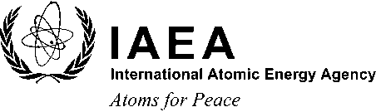
Scientific Forum 2013

The Blue Planet:
Nuclear Applications for a Sustainable Marine Environment
17–18 September 2013
IAEA Headquarters, Vienna, Austria

To register for the Scientific Forum, please send the completed form either by email to: ScientificForum2013@iaea.org or by fax to the following fax number at the IAEA: +43 1 2600 29325. Please note that registrations after 13 September 2013 need to be accompanied by a nomination from the participant’s Government.
* Salutation (Mr/Ms):
* Family Name:
* First Name:
* Nationality:
* Institution/Affiliation:
* Address:
* Postal Code:
* Town/City
* Country:
* Email:
* Telephone (including area code):
Fax:
Mailing Address:
(if different from the address given above)
* Qualifications for attending this event:
Note: The IAEA cannot provide any financial, logistical or visa assistance in connection with the Scientific Forum. Seating capacity in the meeting room is limited.
* Mandatory Fields

