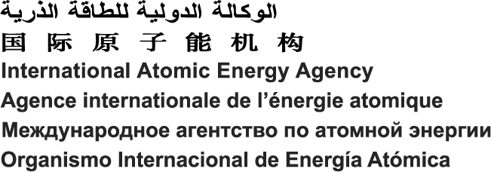

 | Contact: | Martina Khaelss (CN-199), CSS, x21315 |  |  |  |  |  | ORACLE SID:
 | (For IAEA Use) | Name | Division | Extension |  |  |  | ( For IAEA Use )
BANKING DETAILS
PLEASE TYPE OR PRINT IN BLOCK LETTERS (See reverse for further instructions)
 | GENERAL INFORMATION
 |  | Account Name |  | : Mrs. / Mr.
 |  | Account Holder  If (3rd Party) |  | : Mrs. / Mr.
 |  | Bank Name |  | :
 |  | Bank Branch & Address |  | :
 |  | Transit / BSB / Sort / Branch Code |  | :
 |  | ACH Routing / ABA Number (for USA Banks only) |  | :
 |  | SWIFT / BIC |  | :
 |  | Bank Country |  | :
 |  | IBAN (for Europe & IBAN countries) |  | :
 |  | Account Number (Other than IBAN holding countries) |  | :
 |  | Account Currency |  | :
 |  | Intermediary Bank Name (if any) |  | :
 |  | Intermediary Bank Branch |  | :
 |  | Intermediary SWIFT / BIC |  | :
 |  | Interbank Account |  | :

Please mail or fax the completed form to: |  | PAYEE: By signing below, I absolve IAEA of any liability arising from payments to a third party.
International Atomic Energy Agency
Division of Budget and Finance, A0633 |  |  | Name
Fax: +43(1) 2600 29129
P.O. Box 100 |  |  | Position in Organization  / /
A-1400 Vienna, AUSTRIA
 |  |  | Date Signature

Please Note:

1) Only one bank account per currency will be accepted.

2) Fund transfers in any currency other than the account currency will be automatically converted by the receiving bank.

3) Please provide complete and correct bank details, as the payee is responsible for the data. The IAEA is not responsible for any delay in payments resulting from changes in banking information that have not been promptly communicated to the IAEA.

4) In event that the IAEA incurs any bank charges as the result of the provision of incorrect or incomplete information, the IAEA may deduct such charges from any subsequent payment.

Field Description

General Information:
These are the details, which are common to all types of bank accounts.

Account Name: Exact name of person or organization to which payment is due.
Account Holder: Fill in only in case it is different from PAYEE (Third party payment):
Exact name on the account. In case of joint ownership, it should contain the full names.
Please cross out the irrelevant title (Mrs./ Mr.) make sure that surname (Family name) is followed by first name.
Bank Name: Full name without acronyms or abbreviations.
Bank Branch & Address: Exact name and address of the branch.
Transit / BSB / Sort / Branch Code: Canada / Bank-State-Branch Australia / UK / Rest of the world
ACH Routing / ABA Number (for USA Banks only): Automated Clearing House Routing / American Bank Association Number
SWIFT: This stands for Society for Worldwide Inter-bank Financial Telecommunication and contains 8 alpha-numeric characters for the bank and another 3 for the branch.
BIC: Same as the SWIFT code. It contains 8 or 11 alpha-numeric characters (where the final 3 characters are the branch indicator). Both IBAN and BIC can be found on the bank account statement.
Bank Country: Name of the country where the bank resides.
IBAN: Stands for International Bank Account Number and is used by nearly all the countries in Europe and many individual banks around the world. It has a different structure according to different countries’ national rules, but it always begins with two letters of the country code and two “check” numbers, followed by the bank code and account number.
Account Number: Should be correct and exact. Other than the IBAN holding countries “Rest of the world”.
Account Currency: The base currency in which the banks account is held.

Intermediary Bank:
Some banks can receive fund transfers only through a third bank, also called intermediary or pay through bank.

Bank Name: Same as above.
Bank Address: Same as above.
SWIFT: Same as above.
Inter-bank Account: This is the account number of the beneficiary’s bank with the intermediary bank

