FORM A
622-I3-TM-44899
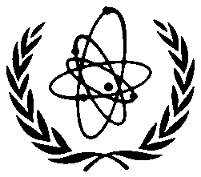
INTERNATIONAL ATOMIC ENERGY AGENCY

TECHNICAL MEETING ON
FAST REACTORS AND RELATED FUEL CYCLE FACILITIES WITH IMPROVED ECONOMIC CHARACTERISTICS

IAEA Headquarters
Vienna, Austria

11–13 September 2013

To be sent to the competent official authority (Ministry of Foreign Affairs or National Atomic Energy Authority) for transmission to the International Atomic Energy Agency, Vienna International Centre, PO Box 100, 1400 Vienna, Austria.

PARTICIPATION FORM
- DEADLINE FOR SUBMISSION: 15 AUGUST 2013
Family name (Surname): AS IN PASSPORT |  |  | Given name (First name): AS IN PASSPORT | Mr/  Ms
Institution: |  |  | Full address:
Title/Position |  |  | For urgent communications please indicate:  Phone:  Fax:  Email:
Nationality: |  | Designating Government or organization:
Mailing address (if different from address of institution):

Do you intend to present a paper? YES  NO 

Title of paper: .........................................................................................................................................
.........................................................................................................................................
An abstract of my paper is attached? YES  NO 
A passport or national identification card is required for site access.

