FORM A
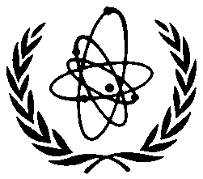
J20-TR-44855

INTERNATIONAL ATOMIC ENERGY AGENCY (IAEA)

Regional Workshop on
Protection of Nuclear Installations against External Hazards

Rio de Janeiro and Angra dos Reis
Brazil
13–17 May 2013

To be sent to the competent official authority (Ministry of Foreign Affairs or National Atomic Energy Authority) for transmission to: Ms Maria Laura Videla, International Seismic Safety Centre, IAEA, Vienna International Centre, PO Box 100, 1400 Vienna, Austria (Fax: +43 1 26007; Email: M.Videla@iaea.org).

PARTICIPATION FORM
Deadline for receipt by IAEA through official channels: 2 April 2013
Family name: |  | All initials of given name: | Mr  Ms
Institution: |  | Full address:
For urgent communications please indicate:
Phone:
Fax:
Email:
Nationality: | Nominating Government:
Mailing address (if different from address of institution):

Do you intend to present a paper? YES □ NO □
Title of the paper:
An abstract of the paper (500 words) is attached? YES □ NO □

