FORM B
F1-TM-44780
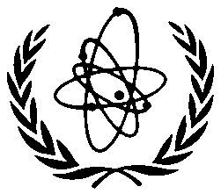
INTERNATIONAL ATOMIC ENERGY AGENCY

Technical Meeting on
Advances in nuclear instrumentation and methods applied for environmental applications and their adoption in the developing Member States with emerging interest in nuclear power

26 – 30 August 2013, IAEA Headquarters, Vienna, Austria

FORM FOR SUBMISSION OF A PAPER

Title of the paper:

Author(s) initial(s) and family name(s) | Scientific establishment(s) in which the work has been carried out |  | Town/Country
1.

2.

3.

4.

Author who will present the paper |  | Mailing address:
Mr./Ms.
Initial(s):
Family name: |  | For urgent communications please indicate:  Telefax no.: Telephone no.:  E-mail:
I hereby agree to assign to the International Atomic Energy Agency
 the Copyright or
 the Non-Exclusive, Royalty-Free License (this option is only for those authors whose parent institution does not allow them to transfer the copyright for work carried out in that institution)
to publish the above-mentioned paper, and certify that no other rights have been granted which could
conflict with the right hereby given to the Agency.

Date: (Signature of Main Author)

To be sent to: Mr. Iain Darby
International Atomic Energy Agency
Wagramer Strasse 5, P.O.Box 100
A-1400 Vienna, Austria
Fax: +43-1-2600-28222

