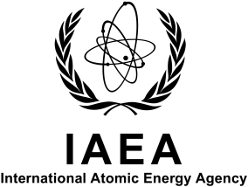
FORM A
F1-TM-44779

INTERNATIONAL ATOMIC ENERGY AGENCY

Technical Meeting on The application of microanalytical techniques based on nuclear spectrometry to the characterization of materials of importance for the nuclear power

7 – 11 October 2013, IAEA Headquarters, Vienna, Austria

To be sent to competent official authority (Ministry of Foreign Affairs, National Atomic Energy Authority) for transmission to the International Atomic Energy Agency, Vienna International Centre, 1400 Vienna, Austria

PARTICIPATION FORM

DEADLINE: 16 August 2013

Family name: |  | All initials of given name: | Mr  Ms
Institution: |  | Full address:
For urgent communications please indicate:
Phone No.:
Telefax No.:
Email:
Nationality: | Designating government or organization:
Mailing address (if different from address of institution):

Do you intend to present a paper? YES □ NO □
Title of the paper:

An abstract of my paper is attached? YES □ NO □

