IAEA-CN-191
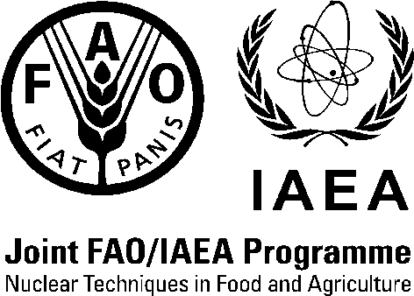

International Symposium on
Managing Soils for Food Security and Climate Change Adaptation and Mitigation

Vienna, Austria

23–27 July 2012

Supplementary Announcement

A. Background
As a result of consultations between the Joint FAO/IAEA Division of Nuclear Techniques in Food and Agriculture in Vienna and the FAO’s Land and Water Division in Rome, it was decided to extend the four-day International Symposium originally scheduled from Monday, 23 July, to Thursday, 26 July 2012, to include Friday, 27 July 2012. The programme on this additional day is intended to focus on the FAO Global Soil Partnership highlighting, in particular, linkages between research and policy development in the soil agenda in order to meet the challenges of improving food security in the context of climate change. The FAO Committee on Agriculture at its 23rd session on 24 May 2012 “endorsed the establishment of the Global Soil Partnership. The venue remains unchanged.
Prospective participants should consult the original Announcement and Call for Papers at the IAEA website for instructions on Symposium registration and other details:
http://www-pub.iaea.org/iaeameetings/41176/International-Conference-on-Managing-Soils-for-Food-Security-and-Climate-Change-Adaptation-and-Mitigation
The Supplementary Announcement provides information on the last Session (day 5) of the Symposium on the Global Soil Partnership (GSP). Contributed papers/statements on this theme will be eligible for inclusion in the Proceedings of the Symposium according to the guidelines posted on the above web site.

B. Target Audience
- Scientists and researchers from national, regional and international organizations (i.e. national agricultural research systems (NARSs), the International Union of Soil Sciences (IUSS), the Consultative Group on International Agricultural Research (CGIAR), the European Commission’s Joint Research Centre (JRC)).
- Selected policymakers and donors (e.g. the Global Environment Facility (GEF), the United Nations Convention to Combat Desertification in Those Countries Experiencing Serious Drought and/or Desertification, particularly in Africa (UNCCD), the United Nations Framework Convention on Climate Change (UNFCCC), UN-Water, the International Soil Reference and Information Centre (ISRIC), the GlobalSoilMap.net project, the Global Soil Forum (GSF)).
C. Programme Structure for Day 5 (27 July 2012)
- Presentation of the Global Soil Partnership (GSP) — vision and mission, objectives, governance, pillars of action and implementation framework;
- Statements/Discussion on the GSP with regard to GSP components and collaboration with related international processes;
- Discussion on linking scientific and technical conclusions from the Symposium (Days 1-4) with 2 key GSP pillars of action: i) promoting sustainable soil management and 2) targeted soil research;
- Discussion in working groups on priority areas for action and concrete proposals for partnership and report back
- Becoming a partner of the GSP (e.g. NARSs, CGIAR participants, etc.)- Interactive process for the development of a collaborative actions with partners;
- Plenary conclusions and recommendations regarding the implementation of the GSP.
D. FAO Focal Point
All enquiries regarding contributed and invited papers for Session 5 (27 July) should be directed to:
Mr Parviz Koohafkan
Director, Land and Water Division
Food and Agriculture Organization of the United Nations
Viale delle Terme di Caracalla
00153 ROME, ITALY
Emails: Parviz.Koohafkan@fao.org; GSP-Secretariat@fao.org
Website: www.fao.org/globalsoilpartnership
E. IAEA Symposium Secretariat

Scientific Secretary:
Mr Minh-Long Nguyen
Joint FAO/IAEA Division of Nuclear Techniques in Food and Agriculture
International Atomic Energy Agency
Vienna International Centre, PO Box 100
1400 VIENNA, AUSTRIA
Tel.: +43 1 2600 21648
Email: M.Nguyen@iaea.org

Assistance to Scientific Secretary:

Ms Jordana Antal
Joint FAO/IAEA Division of Nuclear Techniques in Food and Agriculture
International Atomic Energy Agency
Vienna International Centre, PO Box 100
1400 VIENNA, AUSTRIA
Tel.: +43 1 2600 26843
Email: SWMCN-Symposium2012@iaea.org

Mr Phillip Chalk
Joint FAO/IAEA Division of Nuclear Techniques in Food and Agriculture
International Atomic Energy Agency
Vienna International Centre, PO Box 100
1400 VIENNA, AUSTRIA
Tel.: +43 1 2600 21693
Email: SWMCN-Symposium2012@iaea.org

Administration and Organization:
Ms Karen Morrison
Conference Services Section
Division of Conference and Document Services
International Atomic Energy Agency
Vienna International Centre, PO Box 100
1400 VIENNA, AUSTRIA
Tel.: +43 1 2600 21317
Email: K.Morrison@iaea.org

