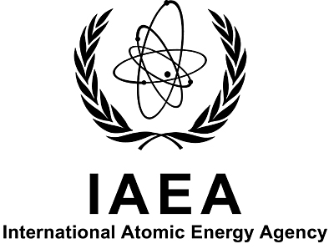

Joint IAEA–CNSC Workshop on Regulatory Activities Associated with NPP Full-Scope Simulator Training and Testing
Toronto, Canada
21–23 August 2012

To be sent to the competent official authority (Ministry of Foreign Affairs or National Atomic Energy Authority) for transmission to the International Atomic Energy Agency, Vienna International Centre, PO Box 100, 1400 Vienna, Austria (Fax: +43 1 26007).

PARTICIPATION FORM

FAMILY NAME: |  |  |  | GIVEN NAMES: | Mr /Ms
INSTITUTION: |  |  | FULL ADDRESS:
TEL.:

FAX:

EMAIL:

NATIONALITY: |  | DESIGNATING GOVERNMENT OR ORGANIZATION:
MAILING ADDRESS (IF DIFFERENT FROM THE ADDRESS INDICATED ABOVE):

Do you intend to MAKE a presentation? Yes No

Title of presentation:

