Feasibility Study on Deployment of the First Unit of RUTA-70 Reactor in Obninsk: District Heating, Technological, and Medical Applications

Yu.S. Cherepnin^{а}, A.A. Romenkov^{а}, F.Ye. Yermoshin^{а}
V.M. Poplavskiy^{b}, Yu.D. Baranaev ^{b}, V.A. Sozonyuk^{b}

ª Research and Development Institute of Power Engineering (NIKIET), Moscow, Russia

^{b} State Scientific Center of the Russian Federation –Institute of Physics and Power Engineering (SRC RF-IPPE), Obninsk, Russia
Summary
This report presents a feasibility study on deployment of the first-of-kind RUTA-70 heat supply facility in Obninsk and prospects of various nuclear technological applications of the reactor. Major technical data of the reactor facility and a description of design are presented. The feasibility of using low-grade thermal energy generated by the reactor for district heating is shown. Aspects of using the reactor as a neutron source to implement modern nuclear technologies and using it for desalination of seawater are considered.
Introduction
The understanding that it is technically feasible to use nuclear heat sources both in domestic district heating systems and in industrial processes, e.g. in seawater desalination systems, was shaped at the very onset of nuclear power development. The currently existing experience shows that there are no technical obstacles to such use of nuclear reactors and any reactor of any power can be used for these purposes [1, 2].
Utilization of nuclear power in domestic district heating has a long history supported by an extensive experience in practical operation of nuclear facilities of various types. However, nuclear power has not yet made any great advance into the commercial heat market. Nowadays, nuclear reactors in the world generate less than 1% of the heat used for district heating and in industrial processes [3] while the share of nuclear power plants in electricity production worldwide being ~15%.
Still, Russia has been recently showing signs of a newly emerging interest in employing atomic energy for district heating, specifically to solve the problem of fuel supplies in remote isolated regions and in connection with reforming of the housing and communal sector. One of the directions of work in this area is creation of specialized district heating facilities based on pool-type reactors intended to generate low-grade heat to meet the demands of the housing and communal sector [4].
One of the advanced projects in this field is the reactor facility RUTA (Reactor Facility for Heat Supply with Atmospheric Pressure in the Primary Circuit) developed originally for dedicated use in district heating systems.
Basic engineering approaches and design of the RUTA-70 reactor
The RUTA-70 reactor (see Figure 1) is a special modification of a pool-type water-cooled water-moderated reactor. To date, options of the RUTA reactors with a thermal power from 10 to 70 MW have been studied to a different extent [5]. The basic technical data of the RUTA-70 reactor facility are presented in Table 1.

Table 1 – Basic technical data of the RUTA-70 reactor
Maximum thermal power of the reactor (N_{nom}), MW | 70
Primary coolant circulation:  - up to 30% N_{nom}  - from 30 to 100% N_{nom} | Natural  Forced
Core heat removal | Two-circuit*
Pressure in the air space over the reactor | Atmospheric
Core dimensions (equ. diameter/height), m | 1.42/1.4
Fuel | Cermet  (0.6 UO₂+ 0.4 Al alloy)
Fuel enrichment in ²³⁵U, % | 4.2
Uranium core load, kg | 4 165
Number of fuel assemblies | 91
Nuclear fuel life, eff. days | 2 332
Refueling cycle with capacity factor of 0.7, years | 3
Share of refueling | 1/3
Water inventory in the reactor tank, m³ | 250
Core temperature (inlet/outlet), ºC | 75 / 101
* The tertiary circuit is considered as a system external to the reactor facility.

The major advantages of the RUTA reactor facility are as follows:
- Basically simple design and, as a consequence, low cost of the reactor facility construction and operation.
- High level of safety achieved through design specific features and using intrinsic safety mechanisms.
The following factors largely define these advantages:
- absence of excessive coolant pressure in the primary circuit (reactor pool);
- presence of a large heat accumulating capacity of the water in the pool;
- low heat rating in the core;
- core cooling in a range from the lowest level up to 30% N_{nom}, as well as in cooldown modes thanks to the natural coolant circulation in the reactor;
- a three-circuit system of heat supply to consumers with the lowest water pressure being in the primary circuit.
Safety as well as reliability and simplicity of the RUTA reactor design depend largely on the absence of excessive coolant pressure in the primary circuit (reactor pool). Such reactors have intrinsic safety properties and can be deployed in the immediate vicinity of heat consumers. This has been also confirmed by long-term experience of operating a great deal of research reactors (in total, 225 such reactors were built in the world, including 23 reactors designed by NIKIET).
The radiation effects of the RUTA facilities on the environment not only during normal operation but in any credible emergencies will not exceed the natural radiation background level.

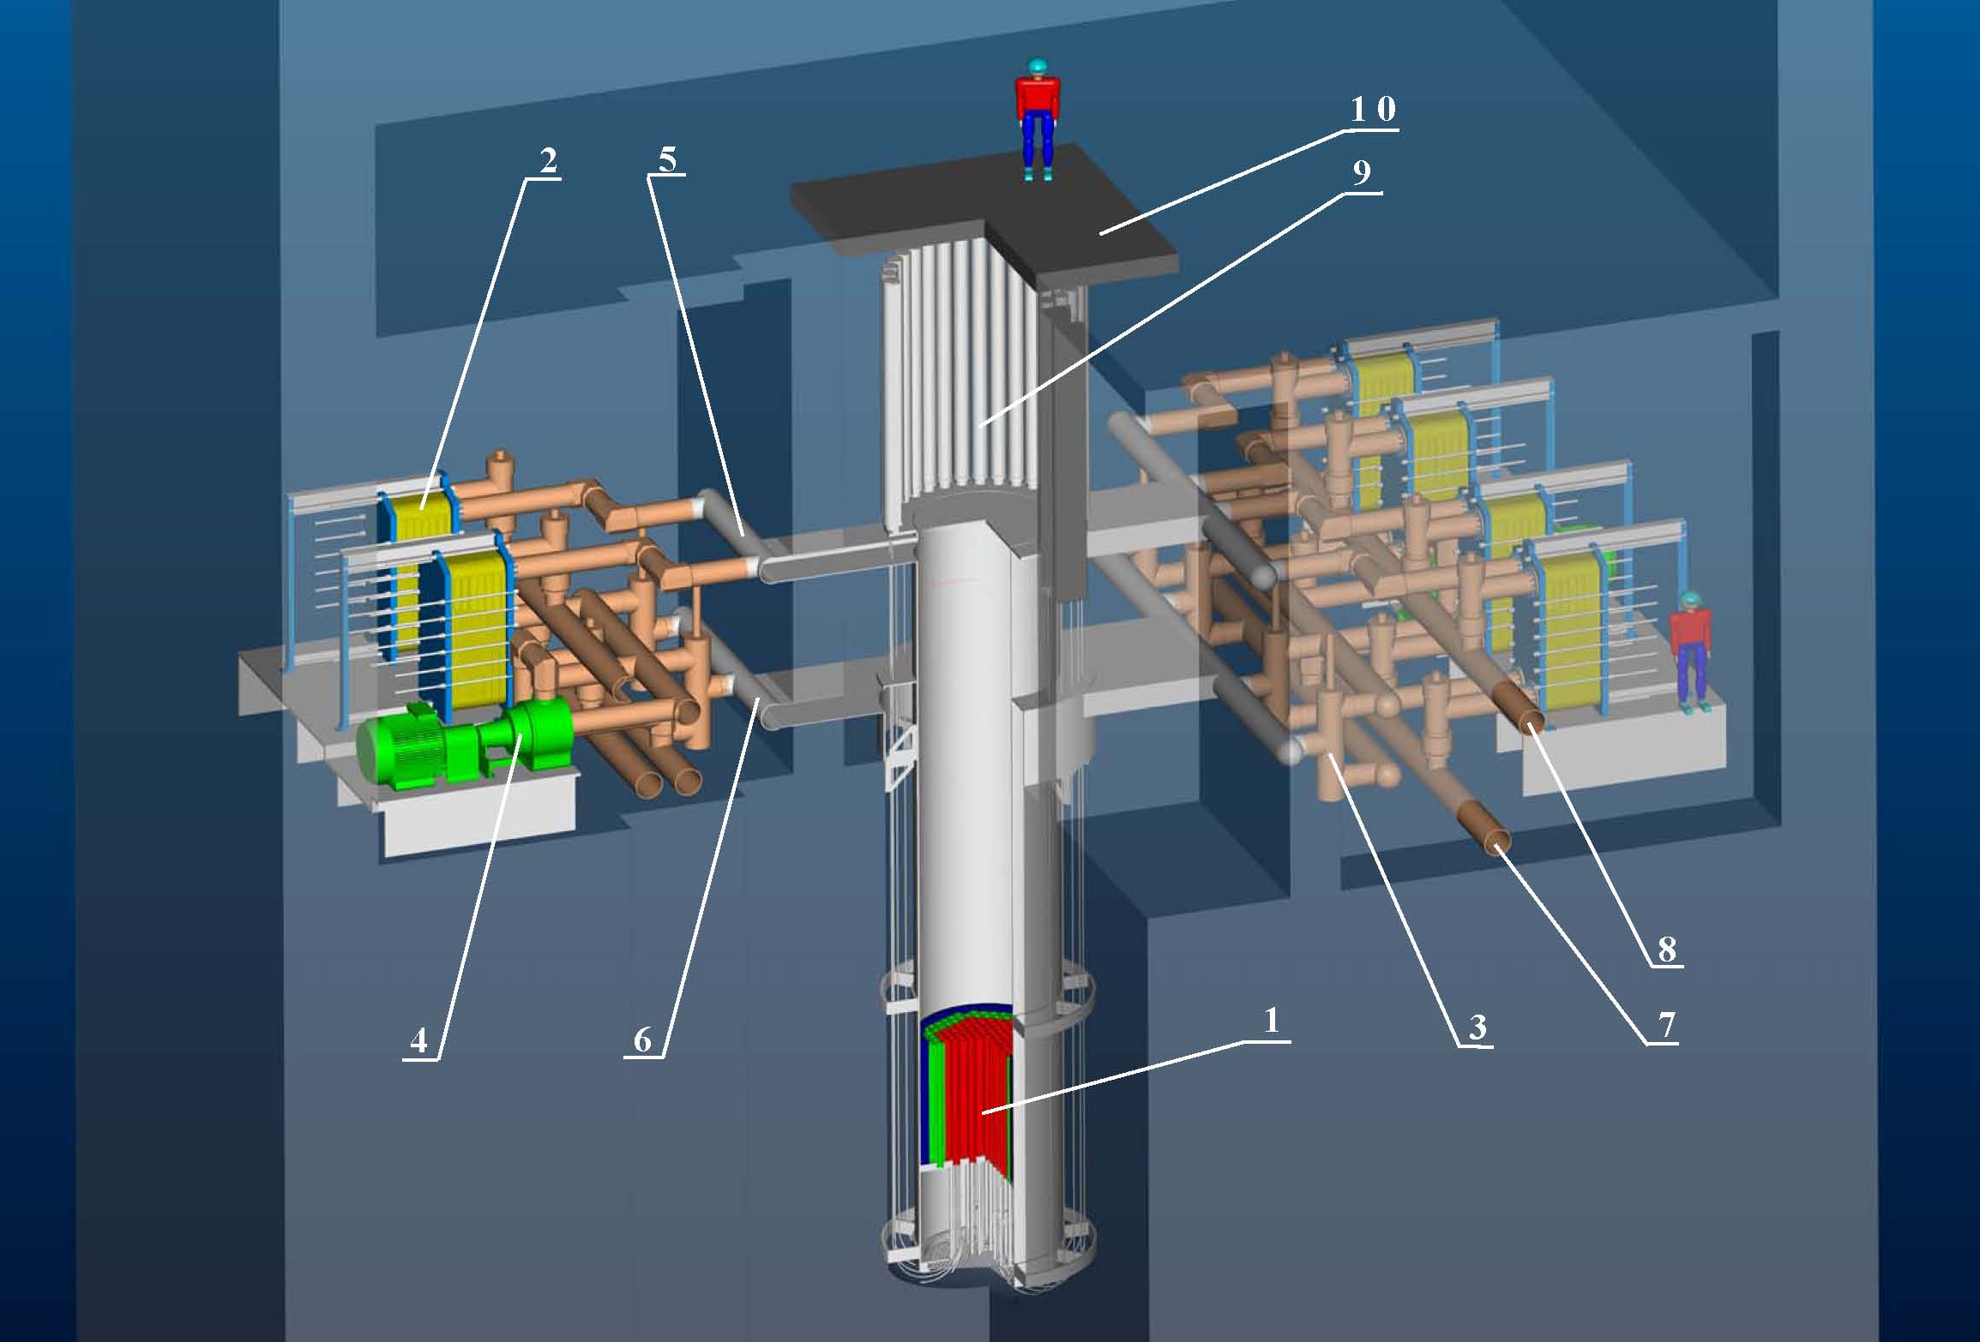
1 – Core; 2 – Primary heat exchanger; 3 – Check valve; 4 – Pump;
5 – Primary circuit distributing header; 6 – Primary circuit collecting header; 7 – Secondary circuit supply pipeline; 8 – Secondary circuit discharge pipeline; 9 – CPS drive; 10 – Upper ceiling.
Figure 1 – RUTA-70 reactor facility

Use of the RUTA reactor for district heating

Marketing studies [6] have shown that Russia has rather a large number of regions where heating supplies can be efficiently ensured through using the RUTA facilities. These are primarily many residential areas covered by local or united centralized power supply systems but lacking sufficient fuel required by heat supply facilities.

The key feature of pool-type reactors is absence of excessive pool pressure and, consequently, low temperature of the system water, so rational ways to achieve reliable heat supply define the following approach to shaping heat supply systems using RUTA facilities:
- for heat supply systems with the maximum required temperature of main water exceeding the temperature level achievable at the RUTA facility, the latter can and should operate in the base segment of the annual heat load schedule. In this case, system water should be heated to the temperature required in the cold period of the year by fire or electric peak water heaters with the capacity factor of the nuclear power facility to be within 0.6 - 0.8;
- for small low-temperature heat supply systems, the RUTA can ensure full heat supply of consumers throughout the year. Still, the facility will normally operate with a very low (not more than 0.3 - 0.4) capacity factor, which will affect adversely its economics. So, in these cases it is also preferable to use the RUTA facilities in the base segment of the heat load schedule, i.e. jointly with peak non-nuclear heat generators.
Therefore, this heat supply technology normally suggests combined use of nuclear sources (covering the base portion of the heat loads) and nonnuclear sources (operating in the peak and half-peak mode).
In most of the cases, this is the best approach to integrating the RUTA facilities into heat supply systems and enables reliable and economic heat supply.
At the same time, this does not make it impossible to operate the RUTA facilities independently in district heating systems operating in the 90/60°C schedule or in a quantitative load control mode.
The most promising of the sites under consideration for deploying the first-of-kind (pilot) model of such facility is the Institute of Physics and Power Engineering in Obninsk. This site has a unique long-term experience of erecting and operating nuclear power facilities of various types, designs and purposes. It includes the required infrastructure, scientific potential and personnel, which enable implementation of such a project in such short time and at such low cost as possible.
In 2004, enterprises of the Federal Agency for Atomic Energy had prepared a feasibility study (FS) on deploying the first-of-kind RUTA nuclear heating plant (NHP) with a thermal power of 70 MW on the FEI site in Obninsk.
The FS was developed jointly by IPPE (Research Supervisor), NIKIET (General Designer) and AEP (General Architect-Engineer) of the facility.
The FS development has helped to update some of the design approaches for the basic layouts and assemblies of the RUTA reactor facility and consider the issues of integrating the RUTA NHP into the Obninsk heat supply system as well as the basic project concepts.
In particular, the master plan of the NHP has been developed, the construction cost has been estimated and economic, financial and budget efficiency of the plant in the commercial conditions of heat supply to the Obninsk heat supply system has been calculated.
The results of the studies show that, apart from its major purpose of demonstrating the technology to be subsequently commercialized, the first-of-kind RUTA NHP unit at IPPE will ensure pays back of the investments.
Sales of generated heat to consumers in Obninsk gives a notable profit (about 3 million rubles in the 1991 prices) that can be used, in particular, to ensure safe operation of the Institute’s engineering infrastructure.
It should be also noted that an important factor making this project more economically competitive is an expected growth in the organic fuel price. Thus, recent years have shown a major rise in heat tariffs because of a gas price increase, including in the European part of Russia (in Obninsk, the heat tariffs was growing at a rate of ~30% per year in 2002 – 2004).

Use of the RUTA reactor as a neutron source
Given diverse tasks and interests of scientific and production organizations in the city, no less important factor favoring the implementation of the project to build the first-of-kind RUTA facility in Obninsk is feasibility of its multi-purpose application:
- production of a broad range of radionuclides for medical and industrial purposes;
- neutron and transmutation doping of silicon monocrystals for the needs of modern microelectronics;
- creation of neutron beams for ray and capture therapy;
- irradiation of thin polymer films for subsequent production of track membranes;
- performance of operations on neutron activation analysis of ores, mineral, etc.
For these purposes, the following irradiation devices can be used in the reactor:
- irradiation channels in the reflector blocks:
- not less than 8 channels for production of radio isotopes;
- 2 channels for neutron and transmutation doping of silicon ingots;
- 2 pneumatic rabbit system channels for neutron activation analysis;
- external irradiation devices based on produced neutron beams:
- 1 channel for fast-neutron therapy (FNT);
- 1 channel for neutron-capture therapy (NCT);
- 1 channels for irradiation of the polymer film used to produce track membranes (ТМ).
The results of preliminary design studies into the arrangement of irradiation devices at the RUTA reactor are shown in Figure 2.
Table 2 presents characteristics of fluxes for groups of neutrons specifically designated as fast (f), epithermal (at) and thermal (t), at the core center and at locations of special channels and devices at the beginning (b) and at the end (e) of the working cycle. For cells of the reflector’s first row, it shows the spreading of the neutron flux values caused by the location of cells and fuel burn-up.

Table 2 – Neutron fluxes at the core center and at locations of irradiation channels and devices for the beginning and the end of the life, 10¹³ /(cm²⋅s)
Energy of neutrons in group | Central FA |  | First row of the reflector (radioisotope production channel) |  | Silicon doping channel |  | FNT channel, bottom (Al) |  | NCT channel, bottom (Al) |  | Graphite column for TM (layer in the water downcomer region)
Energy of neutrons in group | b | e | b | e | b | e | b | e | b | e | b | e
ϕ_{f} (0.1-10 MeV) | 12.1 | 7.6 | 1.0÷2.6 | 1.4÷2.1 | 0.13 | 0.16 | 1.3 | 1.5 | 0.83 | 1.0 | 0,012 | 0,011
ϕ_{at} (1 eV – 100 keV) | 5.8 | 3.7 | 1.1÷2.4 | 1.3÷1.9 | 0.11 | 0.13 | 1.2 | 1.4 | 0.76 | 0.89 | 0,036 | 0,037
ϕ_{t} (less than 1 eV) | 3.8 | 2.6 | 7.0÷9.6 | 6.0÷6.5 | 1.8 | 2.3 | 4.6 | 5.4 | 2.8 | 2.9 | 1,28 | 1,38

The adopted design approaches stipulate such in-pile arrangement of special-purpose channels and devices, which provides for their smallest influence on the neutronic and fuel characteristics of the core with specific requirements to parameters of neutron fluxes in irradiation channels and devices being met.

1 - reactor vessel; 2 – cover; 3 – core; 4 – FNT channel; 5 – film irradiation devices;
6 – fresh film cartridge; 7 – irradiated film cartridge 8 – TV camera; 9 – silicon nuclear doping channel; 10 – power density monitoring sensor; 11– CPS cluster; 12 – IC channel; 13 – CPS drive area; 14 – drive area trunk; 15 – handling trolley; 16 – cooling pool; 17 – upper ceiling.

Figure 2 – Irradiation devices at the RUTA reactor

Use of the RUTA reactor for seawater desalination
The RUTA reactor facility can be used efficiently as a source of low-grade heat for desalination of seawater as part of а nuclear desalination complex (NDC). In the reactor and desalination facility coupling, the tertiary circuit of the reactor facility is the circuit for heating agent of multi-stage distillation evaporators (MED technology). The RUTA NDC uses Russian-developed DOU GTPA desalination facilities (distilling desalination facilities with horizontal-tube film apparatuses) adapted to the reactor parameters.
The self-evaporator operation parameters make it possible to produce a brine boiling temperature of about 85^{о}C at the DOU head stage. The capacity of the NDC based on the RUTA-70 reactor will be about 30 000 m³/day with acceptable distillate cost values.
Economic estimates show that NDCs with the RUTA-70 reactor are capable of competing similar fossil-fuel desalination units relying on expensive outside fuel supplies in the regions of the world with water shortage.
Conclusions
Thanks to technical concepts used in reactor design and low coolant parameters, the RUTA-70 reactor facility features high reliability and as high level of safety and environmental friendliness as possible. This enables deployment of NHPs with the RUTA reactor in the immediate vicinity of the heat consumers. The design simplicity of the reactor and the reactor facility’s essential systems ensures good economic indices with relatively low capital costs contributing to reducing the cost of thermal energy.
The results of studies show that, apart from its basic purpose of demonstrating the technology to be subsequently commercialized, the first-of-kind unit of the RUTA NHP at IPPE pays back the investments.
Developing and introducing based on the RUTA facilities innovative nuclear technologies to ensure knowledge-intensive production for the medical and industrial applications may be also promising at other deployment sites of NHPs with the RUTA reactors. Cities relating to nuclear power both in Russian and abroad as well as territories of scientific centers are most attractive sites for such applications.

References
- Non-electric application of nuclear energy. Proceedings of an Advisory Group meeting held in Jakarta, Indonesia, 21-23 November 1995, IAEA–TECDOC–923, IAEA, Vienna, 1997.
- Nuclear Desalination of Sea Water. Proceedings of an International Symposium held in Taejon, the Republic of Korea, 26-30 May, 1997, IAEA, Vienna, 1997.
- Csik B.J. Assessment of the World Market for Small and Medium Reactors. IAEA–TECDOC–999, 1998, pp. 205-219
- Yu.A. Sergeev. Small Nuclear Power: Status, Prospects and Problems // Teploenergetika, 1995, No.5, pp. 6-11.
- Yu.N. Kuznetsov, A.A. Romenkov, V.I. Mikhan et al. A Pool-Type Reactor for Heat Supply and Desalination. International Workshop «Small Power. Results and Prospects». Moscow, 10-11 October 2001. Moscow, 2001. Collection of Theses, pp. 25-26.
- Ye.A. Volkova, V.S. Shulgina, Yu.A. Mishanina. Prospects of Integrating NHPs with RUTA Reactors into District Heating Systems. International Workshop «Small Power. Results and Prospects». Moscow, 10-11 October 2001. Moscow, 2001. Collection of Theses, pp. 97-98.

